**Interfața grafică – prototip**

**Fereastra Log In:**

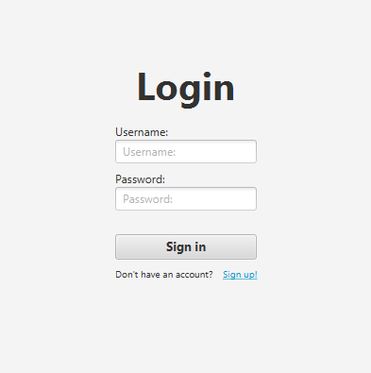

**Fereastra Sign Up:**

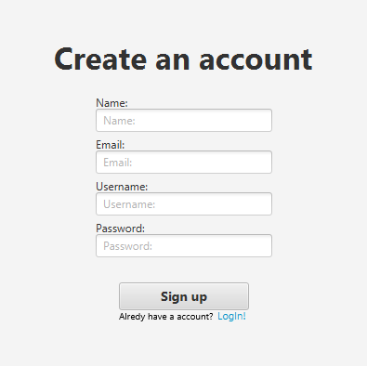

**Fereastra Spectator:**

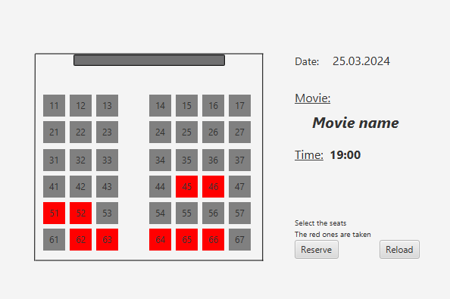

**Fereastra Admin:**

